Kubernetes Activity 1

Client-pod.yml file

Client-node-port.yml file

Push the image of complex-client to docker hub

Now open the powershell as an administrator and start minikube

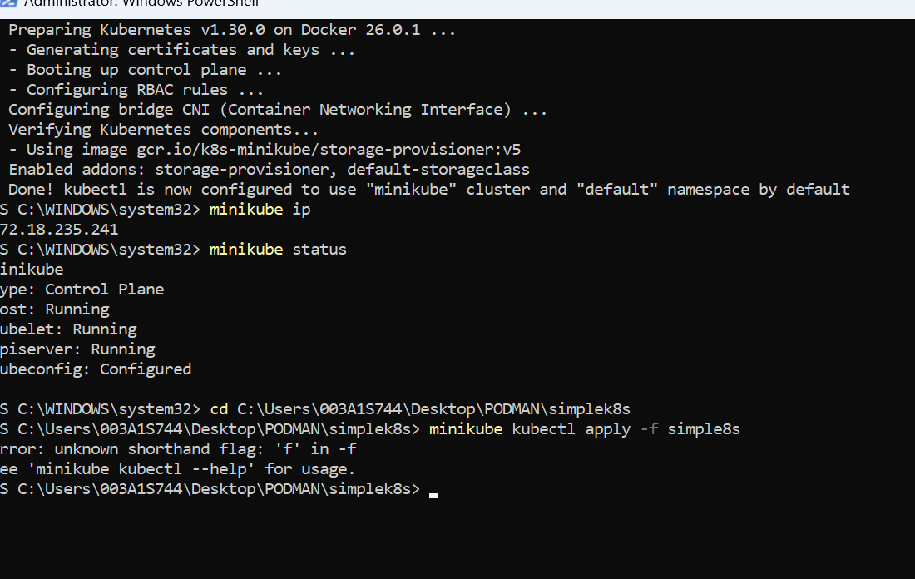

Go to your visual studio and run the below command in the PODMAN folder

--kubectl apply -f simplk8s

Note: We have typed “simplek8s” because we want to upload all the .yml files, if there is a single .yml file the we can give only the file name

Now check minikube ip

Open the browser and type minikube ip with port number mentioned in the .yml file like this “minikube ip : port”

172.18.235.241:31515

Part-2 of Activity1 :

Take client-pod.yml as backup and add a new .yml file “client-deployment.yml”

Open powershell to create “client-deployment.yml”

Run the below commands to see the deployments “kubectl get deployments”

Now describe the “client-deployment”

